IS for Health informatics Application: Digital Dental Application

Ahmed Gamal*, Youssef Mohamed Mahmoud, Youssef Mohamed Ibrahim, Ammar Yasser, Shereen Youssef, Mohamed Omar, Riem M. Hamdi Abdelazim

College of Information Technology, Misr University for Science and Technology, Giza, Egypt.

{89632, 89474 89503, 89650,Shereen Youssef, Mohamed Omar, Riem M. Hamdi Abdelazim}@must.edu.eg

**Abstract:** In dentistry or medicine in general there are a lot of misdiagnosed cases due to human error. The later the diagnosis the worse the case may get. The problem with root fractures is that it usually needs an X-ray and a doctor to be diagnosed but doctors are humans, and they are susceptible to human error.

In this project, we will use AI in dentistry and how it will aid doctors in their work to diagnose root fractures, Doctors will use the application to scan the X-ray of the patient’s tooth and make sure that their diagnosis is 100 percent accurate or even the patient himself can use the app to get a second opinion and make sure that he was diagnosed correctly

**Keywords:** tooth fracture, horizontal fracture, dentistry, tooth fracture detection.

# Introduction

We are humans and it’s normal for us to make mistakes all the time that can be fatal or can cause a patient a lot of pain or suffering so we went on a mission to help doctors detect root-fractured teeth with the help of artificial intelligence.

In dentistry or medicine in general there are a lot of misdiagnosed cases due to human error. The later the diagnosis the worse the case may get. The problem with root fractures is that it usually needs an X-ray and a doctor to be diagnosed but doctors are humans, and they are susceptible to human error.

In this research, we will use AI in dentistry and how it will aid doctors in their work to diagnose root fractures, Doctors will use the application to scan the X-ray of the patient’s tooth and make sure that their diagnosis is 100 percent accurate or even the patient himself can use the app to get a second opinion and make sure that he was diagnosed correctly.

* Corresponding author: [89389@must.edu.eg.](mailto:89389@must.edu.eg)

# Proposed Methodology

Waterfall In the waterfall methodology, the project is divided into distinct phases, including requirements gathering, design, implementation, testing, deployment, and maintenance. Each phase has its own set of activities and deliverables, and once a phase is completed, the project moves on to the next phase. The key characteristic of the waterfall methodology is that it emphasizes strict planning and documentation. Requirements are gathered at the beginning of the project, and the entire project is designed based on these requirements. Once the design is complete, development begins, followed by testing and deployment. Changes made during one phase are generally not carried back to previous phases, making it a linear and rigid approach.

# Results and Discussions

Collective screenshots are taken for the application to showcase the interface and data input and output of the application. Figure 1 below shows actual experience of the dentist using the application

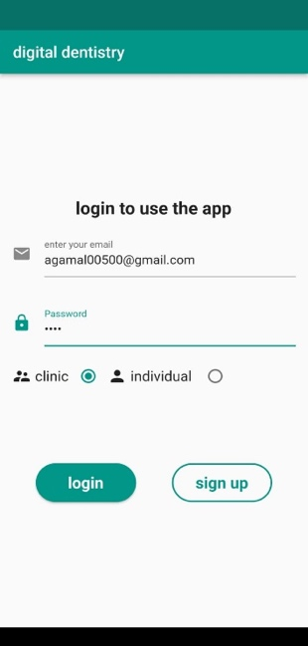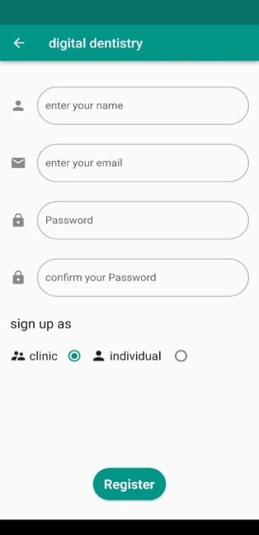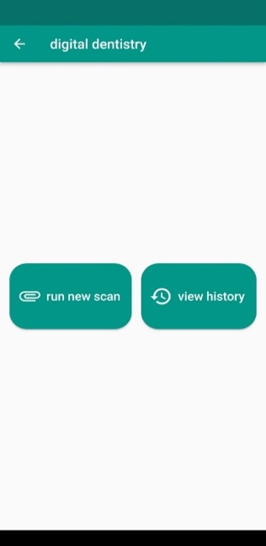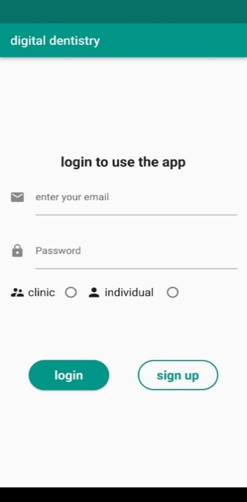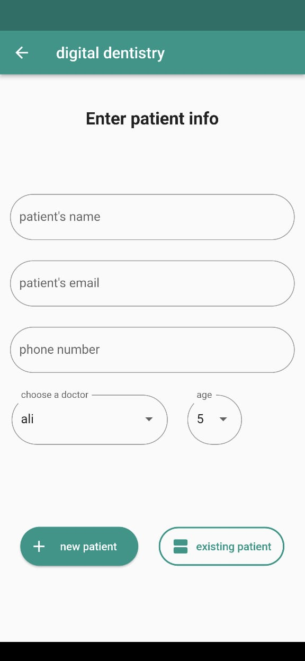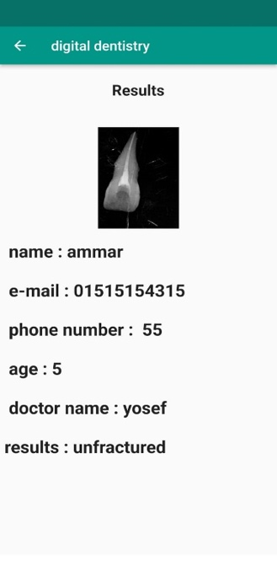

Figure 1. Collection of screenshots of the application for the user to enter data.

1. **DISCUSSION**

The Trained model has scored an accuracy of 95% by using a dataset of more than 4000 images with confusion matrix in figure 2 below.

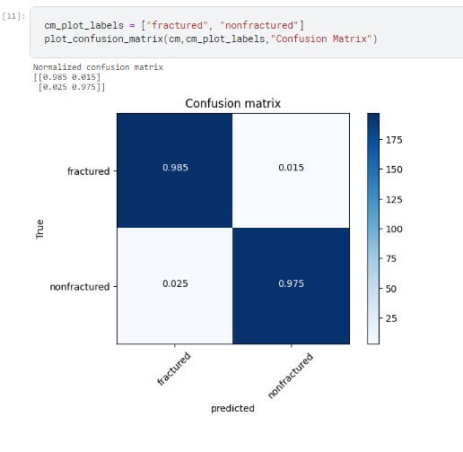

Figure 2. Confusion matrix.

We use in this model TensorFlow library and trained by CNN algorithm, then we used a dataset for teeth such as fractured or not. This model we cannot find anything related to it also the related works we found is not similar to our model. So our model is being trained for the first time to detect if the teeth is fractured or not.

# Conclusions and Future Work

In conclusion, the development of a tooth fracture detection system marks a significant advancement in dental diagnostics and patient care. This project aimed to address the challenges associated with identifying tooth fractures, which often go unnoticed in conventional examinations the tooth fracture detection system developed in this project is a promising new technology that has the potential to revolutionize the way tooth fractures are diagnosed. The system is easy to use and has a high accuracy rate. It is also relatively inexpensive, making it a viable option for use in clinics and individual doctors or user.

# Acknowledgements

We would like to express our special thanks of gratitude to Dr. Eman Fouad, who gave us a golden opportunity to work on this wonderful project. We would like to thank TA Mariem Farid for her cooperation as we came to know so many new things . Also we are grateful to all those who supported us, their contribution ot our knowledge have helped us a lot in our career and we are highly indebt to our dentist friends who were providing us with the necessary information regarding the project and for her support during the process of completing the project.

# References

1. M. Khazaei et al, "Artificial Intelligence-Based Diagnosis of Dental Fractures on Panoramic Radiographs" . in Journal of Clinical and Diagnostic Research, 2021.

[2] Braly BV, Maxwell EH. Potential for tooth fracture in restorative dentistry. J Prosthet Dent. 1981 Apr;45(4):411-4.

[3] Rakhshan V, Sforza C, Vucinic P, Vitalariu AM, De Menezes M. Advanced Digital Dentistry. Int J Dent. 2018 Dec 26;2018

[4] Park WJ, Park JB. History and application of artificial neural networks in dentistry. Eur J Dent. 2018 Oct-Dec;12(4):594-601

[5] Agrawal P, Nikhade P. Artificial Intelligence in Dentistry: Past, Present, and Future. Cureus. 2022 Jul 28;14(7)

[6] Wang P, Yan XB, Lui DG, Zhang WL, Zhang Y, Ma XC. Detection of dental root fractures by using cone-beam computed tomography. Dentomaxillofac Radiol. 2011 Jul

[7] Khasnis SA, Kidiyoor KH, Patil AB, Kenganal SB. Vertical root fractures and their management. J Conserv Dent. 2014 Mar;17(2)

[9] Hung KF, Ai QYH, Leung YY, Yeung AWK. Potential and impact of artificial intelligence algorithms in dento-maxillofacial radiology. Clin Oral Investig. 2022 Sep;26(9) <https://pubmed.ncbi.nlm.nih.gov/35438326/>

[10] Oguz, R. T., Goksel, B., & Cukur, H. (2021). Deep learning-based detection of dental fractures in cone-beam computed tomography images. International Journal of Computer Assisted Radiology and Surgery, 16(1), 1-12.Papers Presented at Conferences: [https://link.springer.com/article/10.1186/s12880-021-00618-z#Bib1](https://link.springer.com/article/10.1186/s12880-021-00618-z%23Bib1)

[11] Chen, H., Liu, X., & Zhang, X. (2020). Automatic detection of dental root fractures using deep learning algorithms. Journal of Endodontics, 46(12), 1738-1744. <https://www.ncbi.nlm.nih.gov/pmc/articles/PMC3520261/>